What’s done so far:
- Video preparation: Each recording is cropped to the top down view of the cage, trimmed to the 5 minutes after the intruder is placed in the cage, converted to greyscale, reduced to 15 frames per second, contrast enhanced, and given a frame counter in the corner.
- Pose estimation: DeepLabCut (the SuperAnimal top view mouse model) places 8 points on each mouse (nose, both ears, center, both flanks, tail base and tail tip). Both mice are tracked in 92 to 99.9 percent of frames. The program also works out which mouse is the resident by looking at the seconds before the intruder is added when only the resident is in the cage.
- SimBA features: SimBA turns the tracked points into the numbers a classifier learns from: distances between the two mice, speeds, body angles and how these change over time. About 550 numbers per frame.
- First measurements without any training: Close proximity episodes (mice within 40 mm) and a simple attack like measure (mice touching while one moves fast) were computed for every video. SimBA's unsupervised clustering was run on the proximity episodes to find repeated movement patterns.
- Supervised classifier: I need the human scored timestamps to learn from in order to complete this.
Results:
Times count from the moment the intruder is placed in the cage. The attack like bouts are from a simple rule, not from a trained model, so they are only useful for comparing sessions with each other.
Video | Clip length | Both mice tracked | Resident found | Time within 40 mm | Attack like bouts
10.3.25.ELS580 | 32 s | 92% | yes | 60% | 9
10.3.25.ELS589 | 300 s | 96% | yes | 42% | 39
8.1.26.ELS693 | 121 s | 99% | yes | 73% | 19
8.1.26.ELS719 | 300 s | 99.9% | yes | 73% | 15
8.3.26.ELS663 | 300 s | 99.5% | unsure | 74% | 14

Examples:
Red points are mouse 1, green points are mouse 2. The frames include huddles, which are the hardest case.
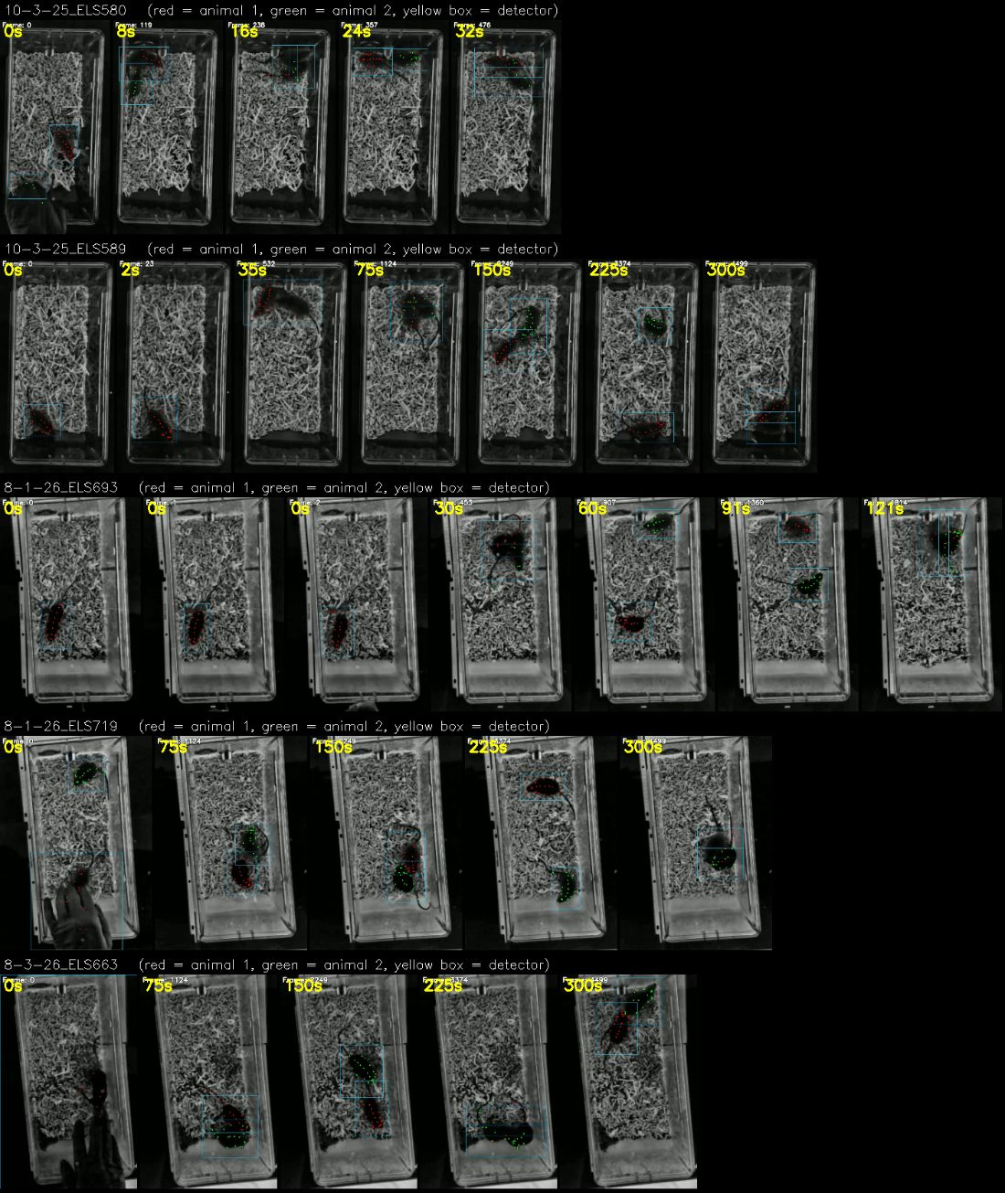
Please have a look and tell me whether you would score this as an attack.
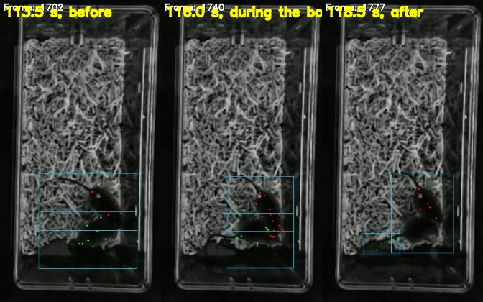
Before, during and after the bout with the tracking overlay.
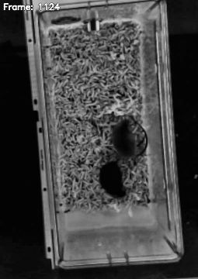
Whats left:
- Train the attack and social investigation classifier. This needs the timestamps below and then runs in a few minutes.
- Rerun the clustering on the real attack bouts instead of the proximity episodes.
- Check the tracking against a small set of hand labelled frames. It has only been checked by eye so far. Labelling about 100 frames gives a real accuracy number and is also the first step if the model needs to be tuned to this cage.
- Add more videos. Five is a small training set. Eight to twelve fully scored videos is the usual minimum for a reliable classifier. New videos only need a crop rectangle and the intruder entry time.

What I need:
- Timestamps of attacks and social investigation. One line per bout with the video name, the behavior, the start time and the end time.
- Which mouse is the resident in 8.3.26.ELS663.
- The inside width of the cage floor in millimetres. All distances and speeds are scaled by it. I have assumed 195 mm.
- Your assumption of what an attack or social investigation is so the scoring is consistent

Important:
- The attack like counts above are a placeholder. The real numbers come from the trained classifier.

